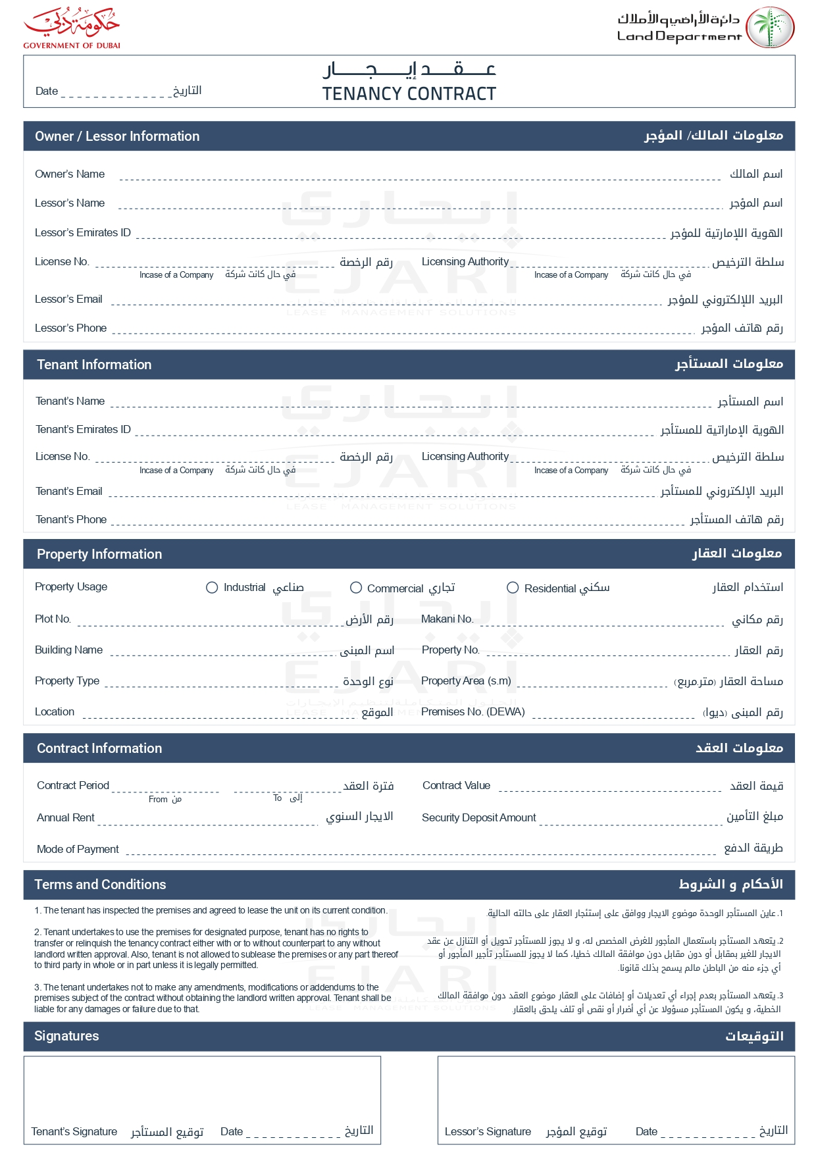

2025-05-02

Cyber Zayed

Fatima Zayed

info@cyberkemet.com

+201210165412

Emily Brown

emily.b@example.com

+971505678901

✓

G-201

Green Apartments

1,200.00

GA001

10,500.00 USD

2025-10-01

2025-05-01

0.00 USD

10,500.00 USD

Monthly

